Sprint 02

**Signs with Smart Connectivity for Better Road Safety**

**Team ID - PNT2022TMID03062**

Sprint Goals:

Push data from local code to cloud

Program Code:

> weather.py

This file is a utility function that fetches the weather from OpenWeatherAPI. It returns only certain required parameters of the API response.

# Python code

import requests as reqs

def get(myLocation,APIKEY): apiURL =

f"https://api.openweathermap.org/data/2.5/weather?q={myLocation}&appid={API KEY}"

responseJSON = (reqs.get(apiURL)).json() returnObject = {

"temperature" : responseJSON['main']['temp'] - 273.15, "weather" : [responseJSON['weather'][_]['main'].lower() for _ in

range(len(responseJSON['weather']))],

"visibility" : responseJSON['visibility']/100, # visibility in percentage where 10km is 100% and 0km is 0%

}

if("rain" in responseJSON):

returnObject["rain"] = [responseJSON["rain"][key] for key in responseJSON["rain"]]

return(returnObject)

> publishData.py

This code pushes data to the cloud and logs data. IBM Cloud is configured such that the data is displayed in the following website: CLICK TO OPEN NODE RED DASHBOARD

# Python code

# IMPORT SECTION STARTS

import wiotp.sdk.device # python -m pip install wiotp import time

# IMPORT SECTION ENDS

#

# API CONFIG SECTION STARTS

myConfig = { "identity" : {

"orgId" : "epmoec", "typeId" : "testDevice", "deviceId" : "device0"

},

"auth" : {

"token" : "?-KDXUPMvDo_TK2&b1"

}

}

# API CONFIG SECTION ENDS

#

# FUNCTIONS SECTION STARTS

def myCommandCallback(cmd): print("recieved cmd : ",cmd)

def logData2Cloud(location,temperature,visibility):

client = wiotp.sdk.device.DeviceClient(config=myConfig,logHandlers=None) client.connect() client.publishEvent(eventId="status",msgFormat="json",data={

"temperature" : temperature, "visibility" : visibility, "location" : location

},qos=0,onPublish=None) client.commandCallback = myCommandCallback client.disconnect()

time.sleep(1)

# FUNCTIONS SECTION ENDS

> brain.py

This file is a utility function that returns only essential information to be displayed at the hardware side and abstracts all the unnecessary details. This is where the code

flow logic is implemented.

from datetime import datetime as dt

from publishData import logData2Cloud as log2cloud

# IMPORT SECTION ENDS

#

# UTILITY LOGIC SECTION STARTS

def processConditions(myLocation,APIKEY,localityInfo): weatherData = weather.get(myLocation,APIKEY)

log2cloud(myLocation,weatherData["temperature"],weatherData["visibility"]) finalSpeed = localityInfo["usualSpeedLimit"] if "rain" not in weatherData else

localityInfo["usualSpeedLimit"]/2

finalSpeed = finalSpeed if weatherData["visibility"]>35 else finalSpeed/2

if(localityInfo["hospitalsNearby"]): # hospital zone

doNotHonk = True else:

if(localityInfo["schools"]["schoolZone"]==False): # neither school nor hospital zone

doNotHonk = False else:

# school zone

now = [dt.now().hour,dt.now().minute] activeTime = [list(map(int,_.split(":"))) for _ in

localityInfo["schools"]["activeTime"]]

doNotHonk = activeTime[0][0]<=now[0]<=activeTime[1][0] and activeTime[0][1]<=now[1]<=activeTime[1][1]

return({

"speed" : finalSpeed, "doNotHonk" : doNotHonk

})

# UTILITY LOGIC SECTION ENDS

> main.py

The code that runs in a forever loop in the micro-controller. This calls all the util functions from other python files and based on the return value transduces changes in the output hardware display.

# Python code

#IMPORT SECTION STARTS

import brain

# IMPORT SECTION ENDS

#

# USER INPUT SECTION STARTS

myLocation = "Chennai,IN"

APIKEY = "bf4a8d480ee05c00952bf65b78ae826b"

localityInfo = { "schools" : {

"schoolZone" : True,

"activeTime" : ["7:00","17:30"] # schools active from 7 AM till 5:30 PM

},

"hospitalsNearby" : False, "usualSpeedLimit" : 40 # in km/hr

}

# USER INPUT SECTION ENDS

#

# MICRO-CONTROLLER CODE STARTS

while True : print(brain.processConditions(myLocation,APIKEY,localityInfo))

'''

MICRO CONTROLLER CODE WILL BE ADDED IN SPRINT 3 AS PER OUR PLANNED SPRINT SCHEDULE

'''

# MICRO-CONTROLLER CODE ENDS

Output :

LINK TO NODE RED DASHBOARD

# Code Output

2022-11-06 21:38:33,452 wiotp.sdk.device.client.DeviceClient INFO Connected successfully: d:epmoec:testDevice:device0

2022-11-06 21:38:33,452 wiotp.sdk.device.client.DeviceClient INFO Disconnected from the IBM Watson IoT Platform

2022-11-06 21:38:33,452 wiotp.sdk.device.client.DeviceClient INFO Closed connection to the IBM Watson IoT Platform

{'speed': 40, 'doNotHonk': False}

2022-11-06 21:38:35,631 wiotp.sdk.device.client.DeviceClient INFO Connected successfully: d:epmoec:testDevice:device0

2022-11-06 21:38:35,631 wiotp.sdk.device.client.DeviceClient INFO Disconnected from the IBM Watson IoT Platform

2022-11-06 21:38:35,631 wiotp.sdk.device.client.DeviceClient INFO Closed connection to the IBM Watson IoT Platform

{'speed': 40, 'doNotHonk': False}

.

.

.

... repeats every 1 sec Images : OutputImage2

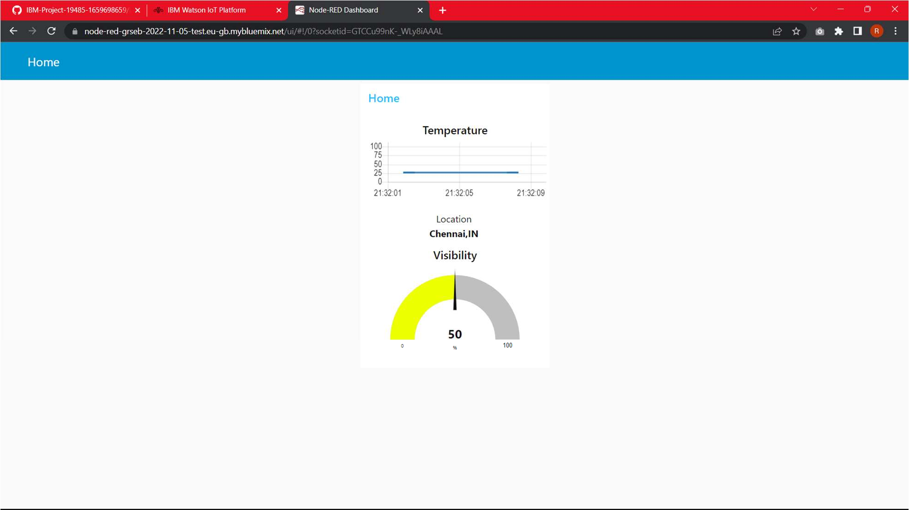

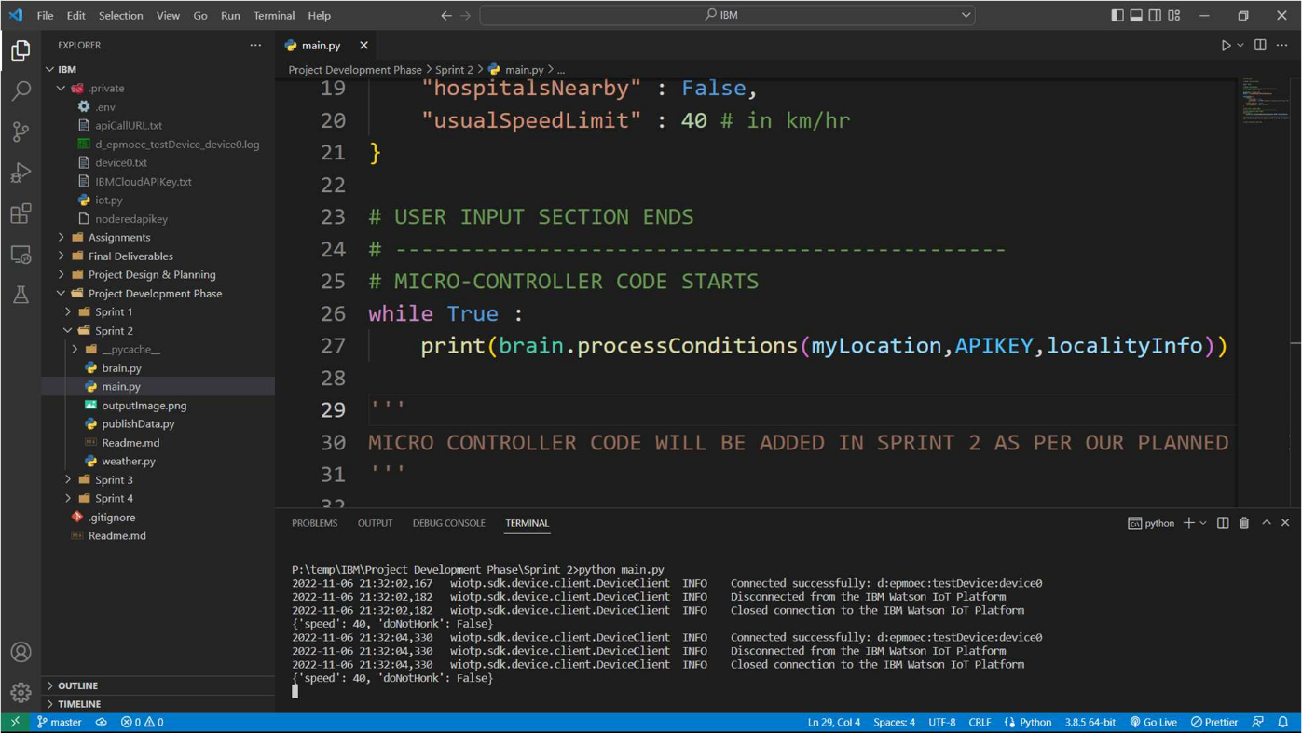Output Image